**Software Requirements and Design Document**

**For**

**Group 2**

Version 1.0

**Authors**:

Jack Garthwaite

Henry Gilbert

Sydney McGinnis

Sophie Pavia

Alex Serrano

1) **Overview**

Our system is an iOS app to tailor exercise routines to its users. After a user answers a few simple questions about themselves the idea is to learn their habits and generate exercise routines for them. The user will have the ability to add their own exercises or choose from a wide variety of provided ones.

The user will be able to track their progress against goals they can set within the app. The goals for example could be just losing weight, toning their body, or even trying to gain weight/build muscle. A calculator in the app will approximate how many calories they should try to consume per day/ how many calories they should burn depending on the information they provide and the kind of goal they are choosing. It will also offer information like the user’s BMI and one max rep.

2) **Functional Requirements**

1. Ability to input weights and workout sets. (high)
2. Ability to log data such as workouts and user provided data. (high)
3. Track user’s progress using a graph. (high)
4. Predict (suggest) workout routines. (low)
5. Integrate into iOS Health App using Health Kit. (low)
6. Create an account through the application. (medium)
7. Motivate the user while working out through motivational quotes. (low)
8. Calculate how a user will achieve their goals. (high)
9. Create custom workouts. (medium)
10. Make users new to fitness feel comfortable. (high)
11. iPad OS support (medium)
12. Calculate the user’s BMI, calories to be burned, and one max reps. (medium)

3) **Nonfunctional Requirements**

1. The application shall protect personal user data by safely storing all workouts and personal data such as height, weight, BMI, goals, and workout progress (high)
2. Include a user friendly and interactive interface (new users won't feel intimidated). (high)
3. Supports mobile phone data so the user has the ability to exercise anywhere and anytime that they would like. (medium)
4. Progress can be shared/accessed across different platforms as long as the user has an account. (iOS and iPad OS) (medium)
5. The application should take less than 5 seconds to switch between screens when the user presses a button. (low)
6. Reliable data management system meaning that the application shall keep a user logged in as long as the application remains downloaded on their iPhone/iPad (high)
7. The application shall remain running and able to use as long as the app is open on the user’s device. (high)

4) **Use Case Diagram**

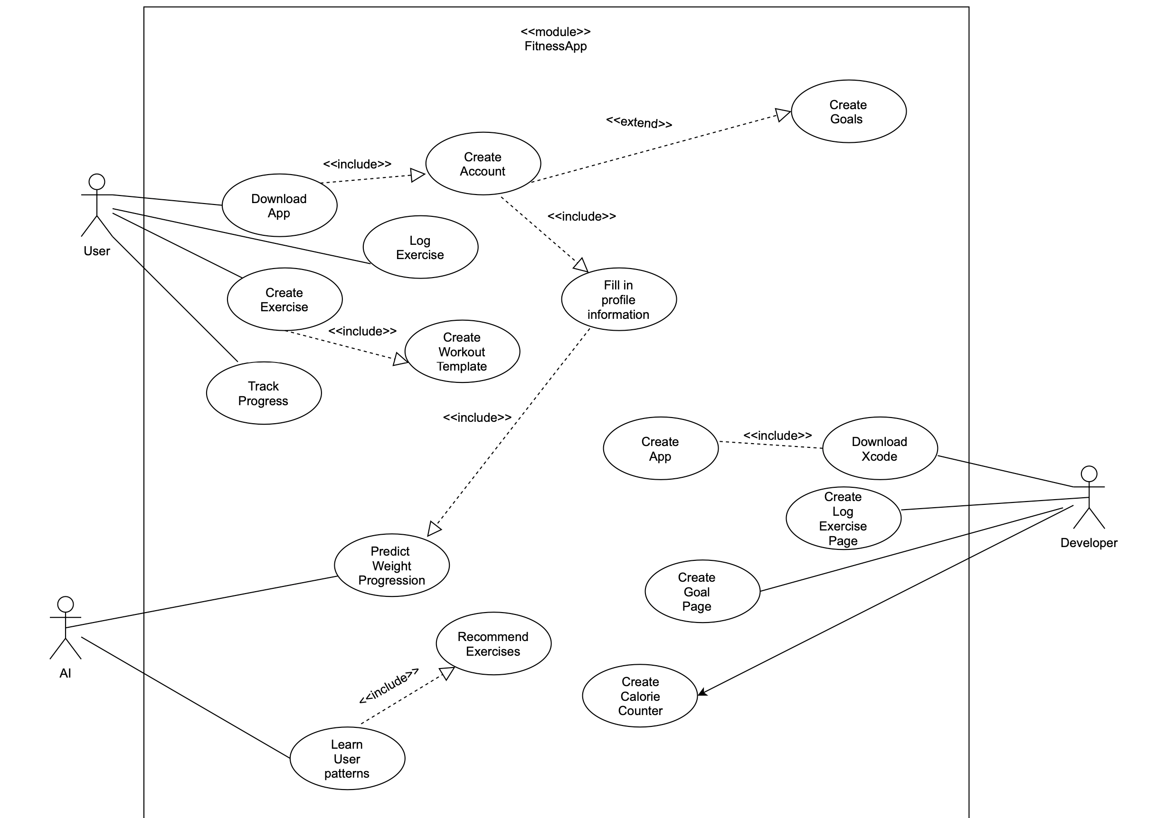

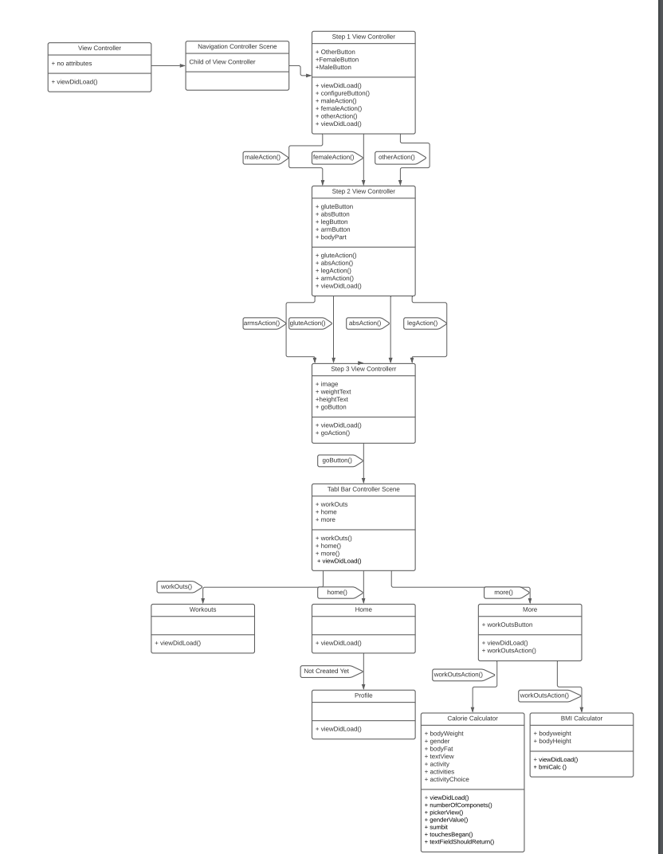

**5)**  **Class Diagram**

6) **Operating Environment**

The application will be developed for the iOS platform for iPhones and iPads, running iOS 14 and above to ensure the user has the most up to date security protections. Since health data is very personal we believe the app should only be supported on devices that will receive and continue to receive security updates. Since the iOS platform is popular, users will have easy access to the app and ensure they are getting the best user experience. Xcode (the compiler) can be accessed across platforms so the user can have a choice of which device to use the app with.

7)***Assumptions and Dependencies***

*We are assuming that for our application, we will be able to upload gifs and pictures from outside sources into the app. If our assumptions are incorrect and gifs are not supported in Swift, then we will not be able to implement this feature when displaying different types of workouts. Another assumption is that we can transition from our application (currently being tested on an iPhone 11) to any other Apple iPhone or iPad. While this is achievable, we are not sure how to format our app so it is portable to different devices yet. If we make changes to the app within an iPhone setting we need to make sure these changes translate to the correct formatting on an iPad too. We intend to implement Apple’s Health App as a stretch goal. While we may not get to this goal as the project continues, we are relying on the health app to be compatible with our app even though we are not fully sure how to implement it. We are assuming it should not be too difficult once we have most of the functionality of the rest of the app completed, but this assumption could be wrong and implementing the health app could pose more of a challenge than we originally thought. An assumption that we have not yet discussed is, will the app need Wifi to work? And if so, how will we let the user use their phone’s data when Wifi is unavailable or limited? This feature is not critical right now to creating the app but it could pose a challenge for us later when we are making the final product.*